Assignment 3

COMP 4107– Assignment 3

Due: Thursday, 11 Mar 2021

Author: Group 29: Devon Robitaille, Graham Shannon, Alex Fillips

Carleton University

# Question 1

## Part (a) – Network Design

1. Reference supplied python code to see how *GradientDescentOptimizer* was implemented.

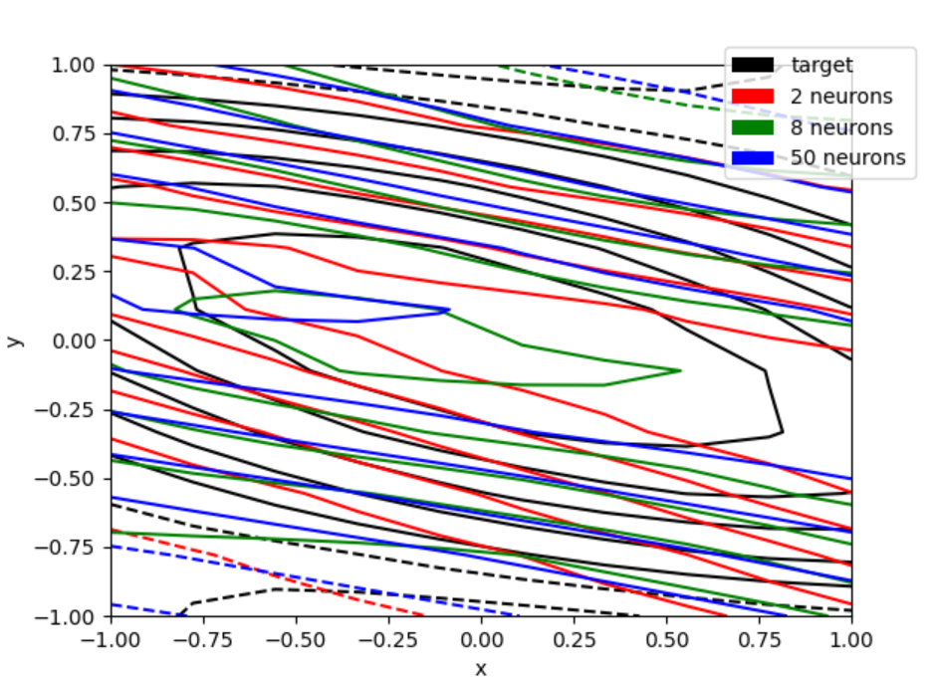

|  |  |  |
| --- | --- | --- |
| **# of Neurons** | **MSE / Loss** | **Epochs** |
| 2 | 0.017898816615343094 | 471 |
| 8 | 0.01566057838499546 | 319 |
| 50 | 0.01958695612847805 | 451 |

1. For our experiments we used the “*tanh*” function as part of the tensorflow library for the activation function of the hidden layers.

## Part (b) – Training